ACCIDENT DETECTION AND ALERT SYSTEM
By
MELISSA ANESU GOTOSA
(H200209J)
HIT400 Capstone project Submitted in Partial Fulfillment of the
Requirements of the degree of
Bachelor of Technology
In
Software Engineering
In the
School of Information Sciences and Technology
Harare Institute of Technology
Zimbabwe


Supervisor
MR MAKONDO
MAY/2024

ABSTRACT
Accidents can occur unexpectedly and pose significant risks to individuals' safety and well-being. Currently, accident reports in Zimbabwe depend upon the people involved or eye witnesses on the accident scenes. It may be the victim who calls for help or the perpetrator. Police and ambulance response time depend on whether a person calls in on time or not. In response to this challenge, the Accident Detection and Alert System is introduced to provide proactive monitoring and timely assistance in the event of accidents.
The Android Accident Detection and Alert System aims to utilize sensors, such as a GPS module, a GSM module, gyroscope or accelerometer and alarm trigger system to detect accidents and promptly notify nearby rescue teams and hospital facilities. By leveraging the capabilities of these sensors, they will sense the accident and raise alarm. The system can accurately detect accidents and send instant alerts to the appropriate authorities, enabling them to take immediate actions. Emergency responders can also send updates upon action has been taken.
By addressing these objectives, the Accident Detection and Alert System aims to enhance safety and minimize the impact of accidents by facilitating swift and coordinated emergency responses. Through the integration of cutting-edge technologies and proactive monitoring capabilities, this system strives to improve overall safety standards and protect individuals in various environments.

PREFACE
In an era where technology plays an increasingly pivotal role in our daily lives, safety remains a paramount concern. Accidents, whether on the road, in the workplace, or at home, can occur suddenly and have far-reaching consequences. Prompt response and effective communication are critical in mitigating the impact of accidents and ensuring the well-being of individuals involved.
With this understanding, the concept of the Accident Detection and Alert System emerged—a proactive solution designed to leverage technological advancements for enhanced safety and emergency response. This system embodies the convergence of innovative sensors, real-time data analysis, and seamless communication channels to detect accidents swiftly and alert relevant authorities and contacts promptly.
The preface of this document serves as an introduction to the Accident Detection and Alert System—a comprehensive exploration of its objectives, functionalities, and underlying principles. By delving into the intricacies of accident detection, location tracking, alert notifications, patient status updates, and manual deactivation mechanisms, this document aims to provide a holistic understanding of how technology can be harnessed to safeguard lives and minimize the impact of unforeseen events.
Through the collective efforts of researchers, engineers, and innovators, the Accident Detection and Alert System embodies a commitment to safety, efficiency, and continuous improvement. As we embark on this journey of exploration and discovery, let us endeavor to create a safer and more secure environment for all.

ACKNOWLEDGEMENT

I would like to express my deepest gratitude to God, whose guidance and blessings have been the cornerstone of my journey. Without His grace, none of this would have been possible.
I am profoundly thankful to my supervisor, Mr. Makondo, for his unwavering support, mentorship, and invaluable insights throughout the development of this project. His expertise and encouragement have been instrumental in shaping my ideas and refining my work.
I extend my appreciation to fellow staff members at the department of software engineering for their collaboration, encouragement, and camaraderie. Their contributions and dedication have enriched this project and made it a collaborative endeavor.
Last but certainly not least, I am indebted to my family—my mom, dad, and siblings—for their unconditional love, unwavering support, and endless encouragement. Their sacrifices and belief in me have been my source of strength and inspiration.
To all who have contributed to this project in any way, I offer my heartfelt thanks. Your support and encouragement have been invaluable, and I am deeply grateful for the opportunity to work alongside such remarkable individuals.



This is to certify that HIT 400 Project entitled “Accident Detection and Alert System” has been completed by Melissa Anesu Gotosa (H200209J) for partial fulfilment of the requirements for the award of Bachelor of Technology degree in Software Engineering. This work is carried out by her under my supervision and has not been submitted earlier for the award of any other degree or diploma in any university to the best of my knowledge.

Your Supervisor Name  Mr Makondo | Approved/Not Approved
Project Supervisor | Project Coordinator
Signature: …………………………… | Signature: …………………………………
Date: …………………………………… | Date: ……………………………………….



Certificate of Declaration
This is to certify that work entitled “Accident Detection and Alert System “is submitted in partial fulfillment of the requirements for the award of Bachelor of Technology (Hons) in Software Engineering, Harare Institute of Technology. It is further certified that no part of research has been submitted to any university for the award of any other degree.

(Supervisor) Signature…………………………….. Date……………………….

(Mentor) Signature…………………………….. Date………………………

(Chairman) Signature……………………………….. Date………………………..

ITEM | TOTAL MARK /% | ACQUIRED/%
PRESENTATION-  Format-Times Roman 12 for ordinary text, Main headings Times Roman 14, spacing 1.5. Chapters and sub-chapters, tables and diagrams should be numbered. Document should be in report form. Range of document pages. Between 50 and 100.Work should be clear and neat | 5
Pre-Chapter Section  Abstract, Preface, Acknowledgements, Dedication & Declaration | 5
Chapter One-Introduction  Background, Problem Statement, Objectives – smart, clearly measurable from your system. Always start with a TO…  Hypothesis, Justification, Proposed Tools  Feasibility study: Technical, Economic & Operational  Project plan –Time plan, Gantt chart | 10
Chapter Two-Literature Review  Introduction, Related work & Conclusion | 10
Chapter Three –Analysis  Information Gathering Tools, Description of system  Data analysis –Using UML context diagrams, DFD of existing system  Evaluation of Alternatives Systems, Functional Analysis of Proposed System-Functional and Non-functional Requirements, User Case Diagrams | 15
Chapter Four –Design  Systems Diagrams –Using UML Context diagrams, DFD, Activity diagrams  Architectural Design-hardware, networking  Database Design –ER diagrams, Normalized Databases  Program Design-Class diagrams, Sequence diagrams, Package diagrams, Pseudo code  Interface Design-Screenshots of user interface | 20
Chapter Five-Implementation & Testing  Pseudo code of major modules /Sample of real code can be written here  Software Testing-Unit, Module, Integration, System, Database & Acceptance | 20
Chapter Six –Conclusions and Recommendations  Results and summary, Recommendations & Future Works | 10
Bibliography –Proper numbering should be used  Appendices –templates of data collection tools, user manual of the working system, sample code, research papers | 5
 | 100 | /100

Project Documentation Marking Guide

Table of Contents
Chapter One- Introduction 1
1.1 Background 1
1.2 Problem Statement 1
1.3 Objectives 1
1.3 Hypothesis 2
1.4 Justification 2
1.5 Proposed Tools 2
1.6 Feasibility Study 2
1.6.1 Technical Feasibility: 2
1.6.2 Economic Feasibility: 3
1.6.3 Operational Feasibility: 4
1.7 Project Plan 5
1.7.1 Time plan 5
1.7.2 Gantt chart 6
Chapter Two-Literature review 7
2.1 Introduction 7
2.2 Conclusion 10
Chapter Three-Analysis 11
3.1 Information gathering tools 11
3.2 Description of the system 11
3.3.1 UML Context level diagram 11
3.3.2 DFD of existing system 12
3.4 Evaluation of alternatives systems 13
3.4 Functional Analysis of Proposed System 14
3.4.1 Functional Requirements: 14
3.4.2 Non-functional Requirements: 15
3.4.3 Use Case 15
Chapter 4- Design 17
4.1 Systems Diagrams 17
4.1.1 UML context diagrams 17
4.1.2 Dfd 18
4.1.3 Activity diagram 18
4.2 Architectural Design 19
4.2.1 Hardware Design 19
4.2.2 Networking Design 20
4.3 Database Design 21
4.3.1 ER Diagrams 21
4.3.2 Normalized Database 22
4.4 Program Design 22
4.4.1 Class Diagram 22
4.4.2 Sequence diagram 23
4.4.3 Package Diagram 24
4.4.4 Pseudocode 25
4.5 Interface Design 27
4.5.1 Screenshots of user interface 27
CHAPTER 5- Implementation & Testing 32
5.1 Sample of real code 32
5.2 Software Testing 34
5.2.1 Unit Testing 34
5.2.2 Module Testing 35
5.2.3 Integration testing 36
5.2.5 Database & Acceptance 38
5.2.6 Acceptance Testing 39
Chapter Six –Conclusions and Recommendations 41
6.1 Results 41
6.2 Summary 41
6. 3 Recommendations: 42
6.4 Future Works: 42
Bibliography 43
Appendix A 45
Appendix B 49

TABLE OF FIGURES
Figure 1 Time Plan 5
Figure 2 Gantt chart 6
Figure 3 existing system uml context diagram 12
Figure 4 Existing system dfd 13
Figure 5 current system use case 16
Figure 6 Current system context diagram 17
Figure 7 Current system dfd 18
Figure 8 Current system activity diagram 19
Figure 9 Current system hardware diagram 20
Figure 10 Current system networking design 21
Figure 11 Current system er diagram 21
Figure 12 Current system normalized database 22
Figure 13 Current system class diagram 23
Figure 14 Current system sequence diagram 24
Figure 15 Current system package diagram 25
Figure 16. User logs into the system 28
Figure 17 User app continuously monitors for accident detection 28
Figure 18 Location coordinates sent to police, hospital, and emergency contacts 29
Figure 19 Current accident location in satellite view with major roads 29
Figure 20 False alarm sms sent if alert was wrong 30
Figure 21 Ambulance logs in 30
Figure 22 Update current patient status and sent to police, and emergency contacts 31

This page was intentionally left blank

Chapter One- Introduction

1.1 Background
Associated with an increase in demand for automobiles, a drastic increase can also be seen in road accidents. As per the data given by WHO approximately 1.35 million people die every year due to road accidents. This number is big enough to show the global crises of road safety and creates a need to improve the road safety facilities and rescue operation systems. The unavailability of developed technologies makes it risky for people as they continue to violate road safety measures. This paper proposes a way to help reduce the accident rate in the country. The system introduced is an Accident Detection and Alert system.
The Android Accident Detection ad Alert System aims to utilize sensors, such as a GPS module, a GSM module, gyroscope or accelerometer and alarm trigger system to detect accidents and promptly notify nearby rescue teams and hospital facilities. By leveraging the capabilities of these sensors, they will sense the accident and raise alarm. The system can accurately detect accidents and send instant alerts to the appropriate authorities, enabling them to take immediate actions. Emergency responders can also send updates upon action has been taken.

1.2 Problem Statement
- In most cases when a road accident takes place, the rescue team or the police authorities are not informed in time.
- Furthermore, the delay caused by the rescue team in reaching the accident site and the heavy traffic congestion in between the accident location and the hospital facilities increases the risk of death for the victim.
- Therefore there is a need for a reliable and efficient system that can detect accidents in real-time and notify the relevant authorities promptly.

1.3 Objectives
- To automatically detect abnormal sound reading and sensor reading, whilst user app continuously senses for accidents in the background.
- To track the location coordinates of the area where accident took place to help determine fastest route to point of collision.
- To send alert notifications to hospitals, police authorities and emergency contacts
- To keep updating status of patient to keep emergency contacts and police prepared and well informed.
- To manually deactivate the emergency alert in case of a false alarm

1.3 Hypothesis
The Android Accident Detection and Alert System utilizing sensors, such as a GPS module, a GSM module, gyroscope or accelerometer and alarm trigger system, will effectively detect accidents and promptly send alert notifications to the appropriate authorities, resulting in faster response times and potentially saving of more lives.

1.4 Justification
- Improved response times: By instantly notifying nearby rescue teams and hospital facilities, the system can significantly reduce response times, leading to quicker medical assistance for accident victims.
- Enhanced safety: The system ensures that accidents are reported promptly, enabling authorities to take immediate actions and secure accident sites.
- Efficient resource allocation: With accurate accident detection and location tracking, emergency services can allocate their resources more effectively, ensuring that the right personnel and equipment are dispatched to the scene.

1.5 Proposed Tools
- React Native: The programming language for Android app development.
- GPS module: To track location coordinates.
- GSM module: To send alert notifications.
- Accelerometer or gyroscope sensor: To detect sudden changes in motion.

1.6 Feasibility Study

1.6.1 Technical Feasibility:
Automatic Detection of Abnormal Sound and Sensor Readings:
  - Feasibility: Found to be feasible with the use of modern sensor technologies and signal processing algorithms.
  - Technical Requirements: Reliable sensors, signal processing algorithms, background sensing capabilities in the user app.
Location Tracking:
  - Feasibility: Found to be feasible using GPS technologies.
  - Technical Requirements: Integration with GPS modules, software development for accurate location tracking.
Alert Notifications:
  - Feasibility: Found to be feasible with available communication technologies (e.g., SMS, email, push notifications).
  - Technical Requirements: Integration with communication APIs, robust notification system.
Patient Status Updates:
  - Feasibility: Found to be feasible with real-time data updating mechanisms.
  - Technical Requirements: Data management system, integration with medical databases, secure data transmission protocols.
Manual Emergency Alert Activation:
  - Feasibility: Feasible with user-friendly interfaces and manual trigger options.
  - Technical Requirements: User interface design, integration with manual trigger mechanisms.

1.6.2 Economic Feasibility:
Cost of Development:
Item Open | Cost ($)
Hardware Components | 450
MySQL | Open Source
Apache Web Server | Open Source
React Native | Open Source
Total Costs | $450

Cost of Maintenance:
Item | Cost ($)
Hardware maintenance | 250
Software maintenance | 150
Accessories and other expenses | 200
Total Costs | $600

Return on Investment (ROI):
  - Feasibility: High potential ROI due to the system's ability to save lives and reduce rescue time.
  - Economic Considerations: Potential savings in healthcare costs, emergency response efficiency, and reduced accident-related losses.

1.6.3 Operational Feasibility:
User Adoption:
  - Feasibility: User adoption is likely to be high due to the system's potential to improve safety.
  - Operational Considerations: User training and education, user feedback and support mechanisms.
Integration with Existing Systems:
  - Feasibility: Integration with hospital and police systems may require collaboration but is feasible with proper coordination.
  - Operational Considerations: Coordination with relevant authorities, data sharing agreements, interoperability testing.
Scalability:
  - Feasibility: The system should be designed to scale up to handle increased user base and data volume.
  - Operational Considerations: Scalable architecture, cloud infrastructure, capacity planning.
Regulatory Compliance:
  - Feasibility: Compliance with relevant regulations and data privacy laws is essential but feasible with proper measures.
  - Operational Considerations: Compliance assessment, data protection measures, regular audits.
Overall, the accident detection and alert system appears to be technically feasible with the availability of modern technologies and economic feasibility due to its potential return on investment. Operational feasibility relies on effective user adoption, system integration, scalability, and regulatory compliance. Proper planning and execution are essential to ensure the success of the system.

1.7 Project Plan

1.7.1 Time plan

PHASE | DURATION(weeks) | STARTING DATE | ENDING DATE
Requirements analysis and definition | 4 weeks | 1 September 2023 | 29 September 2023
System design and software design | 11 weeks | 1 October 2023 | 15 February 2024
Implementation and unit testing | 3weeks | 05 January 2024 | 28 February 2024
Integration and system testing | 4 weeks | 27 March 2024 | 2 April 2024
Figure 1 Time Plan

1.7.2 Gantt chart

Software Development life cycle activities/ Plan | Sept | Oct | Nov | Dec | Jan | Feb | Mar | Apr | May
Project proposal and planning
Requirements gathering and analysis
System Design
System Development
System testing and validation
Implementation
Maintenance
Figure 2 Gantt chart

Chapter Two-Literature review

2.1 Introduction
This literature review seeks to provide a comprehensive overview of existing research and developments in the field of accident and alert systems. By synthesizing and analysing the key findings, methodologies, and challenges documented in the literature, this review aims to elucidate the current state-of-the-art, identify gaps in knowledge, and propose avenues for future research and innovation.
- Accidents Detection and Prevention System to reduce Traffic Hazards using IR Sensors by Naji Taaib Said Al Wadhahi , Shaik Mazhar Hussain , Kamaluddin Mohammad Yosof ; Shaik Ashfaq Hussain , Ajay Vikram Singh
Traffic Hazards is one of the major problems facing across the world. One of the major causes of traffic hazards is increase in vehicles and dense population. Reducing traffic hazards is one the major challenges as majority of the deaths across the world are due to road accidents. Hence there is a need to provide better transportation facilities that can reduce the ratio of road accidents and save life’s of people. One of the solution that is proposed in this paper is using IR sensors and Arduino Uno technology. The system has two phases-Accident Detection and Accident Prevention. The detection phase is carried out using IR sensors that could detect and alert the people by sending SMS using GSM module that contains predefined numbers and accident location using GPS module. Second Phase, Accident prevention is carried out using IR sensors by warning the driver about the neighbouring vehicles when the distance between them is beyond the threshold value [1].
The proposed work is carried out using SDLC methodology. This methodology is organized in two phases. One is in planning phase and the other one is in Implementation phase. Software development Life cycle is the updated version of Waterfall methodology. The cycle involves many stages such as Analysis, Design, Implementation, Planning and Maintenance. Each unit in this methodology is properly tested and evaluated. This is applied both for software and hardware. The SDLC methodology is carried out in various phases such as Plan, test, design and build. In planning phase, the requirements for the design are collated to meet the goals. In analysis stage, two kinds of Analysis are carried out. One is System Analysis and the other one is Preliminary analysis. In preliminary analysis, problem has to be defined. Investigation of goals and objectives should be done. In the design stage, Designer would know the insights of the work. [2] In the Implementation and maintenance stage, program and system testing done.
The proposed design consists of various components such as IR sensor, Crashing switch, GSM module, LCD, LED and RF module Transmitter and Receiver. All these devices are interfaced to Arduino Uno board. The IR sensor and crashing switch is responsible for detecting the accidents and sends the command to the microcontroller. GSM and GPS are the devices that sends SMS and location to the users. [3]
- IoT Based Intelligent System For Vehicle Accident Prevention And Detection At Real Time b Vivek Kinage, Piyush Patil
Our proposed system provides an efficient, cost-effective and real-time solution to prevent vehicle accident. When reading goes beyond predefined threshold values, an alert gets generated and if a driver does not take some action in specified time then our proposed system will handle the situation by cutting the fuel supply. Our proposed system uses a microcontroller named Arduino along with MQ-3 sensor, infrared sensor, accelerometer, and webcam. Arduino is used to regulate all these sensors. [4]
Alcohol Detection
Our proposed system uses MQ-3 sensor to detect the alcohol consumption. The reason to choose MQ-3 sensor is that it is low cost and have high sensitivity to alcohol. It actually detects the ethanol in the air or human breath. It contains total 6 pins. It is basically alumina tube covered by tin oxide. [5] When alcohol molecules in the human breath meet the electrode between SnO2 and alumina, ethanol burns into acetic acid and because of this more current is produced. More the alcohol molecules, more current we will get.
Identify the Headings
Our proposed system uses infrared sensor to monitor the eye of the human being. The infrared sensor contains IR LED and IR photo-diode. Our proposed system uses IR LED to detect eye blink rate. A maximum amount of light is reflected from the eye when the eye is close because when an eye is closed, our skin part of the eye becomes opaque. If minimum amount of light is reflected then we can conclude that vehicle driver is feeling drowsy.
Head Movement Detection
Our proposed system uses accelerometer ADXL330 for detection of head movement. ADXL330 provides 3-axis detection. We have set each accelerometer axis two dedicated LED indicators - red and green. [6]Both LEDs become off when there is no acceleration. One LED become “ON” if there is acceleration in any one direction.
Mouth Detection
Our proposed system uses OpenCV library to monitor mouth. Our proposed algorithm detect the number of yawns from the detected mouth. A closed mouth is often brighter than open mouth. Image captured by camera is converted into Binary Image. As shown in Figure B image has less number of back pixels which indicates mouth is closed and D image indicates mouth is open because of yawn. If the detected yawns are more than threshold then driver gets alerted using voice messages.
Speed Bumper (or Speed Breaker) Detection
The proposed system uses ultrasonic sensor to detect speed bumpers on road. At night, many times these speed bumpers are not visible to us. To solve this problem our system uses the HC-SR04 sensor. It is fixed on the front side of vehicle. It changes its angle of rotation after defined threshold. If the transmitted ray is received by receiver then Speed Bumper is detected else not detected.
- Intelligent Transportation System for Accident Prevention and Detection by Dr.D.Selvathi Professor, P.Pavithra UG Student, T.Preethi UG Student
In this work, a system is designed which checks for alcohol and helmet before engine of the bike is turned on. Helmet use consistently has been shown to reduce motorcycle crash–related injuries and deaths. Universal helmet laws require all motorcyclists to wear helmets whenever they ride. For helmet detection air pressure switch is used, the switch will be closed if helmet is worn. The communication between the helmet and the microcontroller is using RF module. The output of the switch will be given to the RF transmitter and the data will be transmitted. The transmitted data is received by the RF receiver, which is connected to the microcontroller for processing. Alcohol sensor is used as breath analyser which is used to continuously monitor the rider’s breathe and check if it is below the permissible level. MQ-3 sensor is used for this purpose. [7]The engine of the two-wheeler is turned on using the relay. The relay is programmed to be turn on only when these two conditions are satisfied. The next main issue is accident and late medical help. If the rider met with an accident he may not receive medical help instantly, it is one of the major reasons for deaths. For every second people die due to delay in medical help or the accident place is unmanned. This paper provides a solution for this problem by detecting the accident as soon as it occurs and informing it to the respective persons. Accelerometer is used for the accident detection. The accelerometer will continuously monitor the acceleration forces in 3 axes. If any abrupt change is detected in any one of the axes it will be considered as accident. If accident is detected, microcontroller will send the information to the rider’s smart phone via Bluetooth module. The android app in the rider’s smart phone will send a message to the previously registered number in the app. [8] in this paper, Arduino ATMEGA328p is used as microcontroller. The main aim of this paper is focused to prevent and reduce the death rate of two wheeler accidents.
- A Pupil Diameter Measurement System for Accident Prevention Takayuki SHINODA, Student Member, and Masami KATO, Member, IEEE
The pupil diameter of a person changes under various conditions. For instance, the pupil diameter of a person who is thinking becomes large, and in contrast, the pupil diameter of a tired person becomes small. These effects have been proven through a number of psychology experiments 11, 21. The pupil diameter, along with data concerning the blink duration and the change in eye direction are gathered by the proposed system. [9]The system detects the attention level of a person based on the pupil diameter. The recognition rate of a person's attention level has been improved using these ancillary data regarding the blink duration and the change in eye direction arms the driver. Information on the pupil diameter, blink duration and eye movement is obtained by an image processing system capable of real-time detection. A device that has a hot mirror is used to input the images without obstructing the driver's view. In some cases, sunshine or headlights reflect in the pupil, and part of the pupil cannot be detected. This system is designed to correspond to these cases. In addition, the system can be used even if contact lens, glasses, or sunglasses are worn [10].

2.2 Conclusion
In conclusion, this literature review has provided a comprehensive examination of accident and alert systems, highlighting the diverse array of technologies, methodologies, and challenges inherent in this critical domain of safety engineering.

Chapter Three-Analysis
The requirements analysis phase is crucial for developing a successful accident detection and alert system. It involves understanding the needs and expectations of stakeholders, defining system objectives, and identifying the functional and non-functional requirements.

3.1 Information gathering tools
Interviews
Are invaluable for gaining in-depth insights into stakeholders' perspectives, requirements, and expectations regarding an accident detection and alert system. Through direct interaction, interviewers can explore nuances, concerns, and potential use cases in detail. We conducted structured and semi-structured interviews with various stakeholders, including end-users, safety experts, emergency responders, and system developers.
Questionnaires
They provide a systematic way to collect feedback and preferences from a larger sample of stakeholders regarding the accident detection and alert system. They offer insights into broader trends, preferences, and priorities across different user groups. We developed a questionnaire with a mix of closed-ended and open-ended questions and gave them to potential users of the system.

3.2 Description of the system
Currently, accident reports in Zimbabwe depend upon the people involved or eye witnesses on the accident scenes. It may be the victim who calls for help or the perpetrator. Police and ambulance response time depend on whether a person calls in on time or not. In short the following channels of communicating with the emergency responders are currently in use:
- Phone-ins: These are reports received via telephone calls.
- Walk-ins: These are reported by people who physically visit the hospital or police station.
After accident has been reported the relevant personnel is dispatched. The dispatch process basically notifies the responsible team for resolving the reported report.3.3 Data analysis

3.3.1 UML Context level diagram
A UML Context Level Diagram provides a high-level overview of the accident detection and alert system, illustrating the system's interactions with external entities. It helps stakeholders understand the system's boundaries, its relationships with external actors, and the flow of information between them. This diagram identifies the key actors involved in the system and shows how they interact with the accident detection and alert system. It represents the system's interactions with these actors without going into the internal details of the system
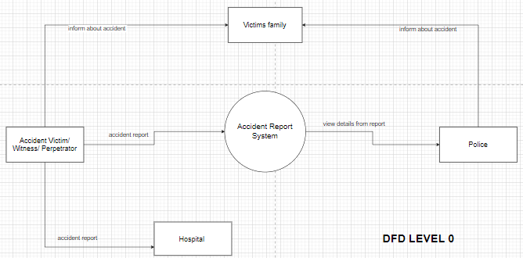
Figure 3 existing system uml context diagram

3.3.2 DFD of existing system
It is a graphical representation of the system that shows the flow of data within the system. It is a visual tool used to depict the flow of data, inputs, and outputs of a system, and the processes that transform the data.
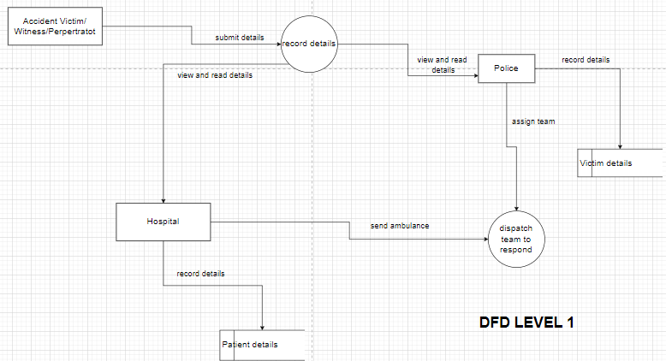
Figure 4 Existing system dfd

3.4 Evaluation of alternatives systems
This section we evaluating alternative systems, considering various factors to determine which system best meets the requirements:
System A: Video-based Detection System
- Pros: This system uses video cameras to detect accidents based on visual cues, such as sudden movements or collisions. It can provide accurate and real-time accident detection.
- Cons: Video-based systems may require a significant infrastructure setup, including cameras and processing power. Privacy concerns may also arise due to continuous video surveillance.
System B: Sensor-based Detection System
- Pros: This system utilizes various sensors, such as accelerometers or gyroscopes, to detect accidents based on impact or sudden changes in motion. It can be cost-effective and efficient.
- Cons: Sensor-based systems may have limitations in accurately distinguishing between normal movements and actual accidents. Calibration and sensor placement may also affect accuracy.
System C: Smartphone-based Detection System
- Pros: This system leverages the sensors and capabilities of smartphones to detect accidents, such as sudden drops or changes in velocity. It is widely accessible and cost-effective.
- Cons: Smartphone-based systems may rely on user compliance and may not be as reliable in situations where the phone is not carried or is out of battery.
System D: Vehicle Telematics-based Detection System
- Pros: This system utilizes vehicle telematics data, such as sudden deceleration or airbag deployment, to detect accidents. It can provide accurate and reliable accident detection for vehicles.
- Cons: Vehicle telematics-based systems are limited to accidents involving vehicles and may not cover accidents involving pedestrians or cyclists.
System E: Machine Learning-based Detection System
- Pros: This system employs machine learning algorithms to analyse various data sources, such as sensor readings or audio patterns, to detect accidents. It can adapt and improve over time.
- Cons: Machine learning-based systems require significant amounts of labelled training data and continuous updates to maintain accuracy. They may also be computationally intensive.
System F: Crowd-sourced Detection System
- Pros: This system relies on inputs from multiple users or witnesses to report accidents. It can provide a wide coverage area and real-time information from various perspectives.
- Cons: Crowd-sourced systems may be dependent on user participation and may have limitations in accuracy and reliability. False reports or delays in reporting may occur

3.4 Functional Analysis of Proposed System

3.4.1 Functional Requirements:
The purpose of this study ensures that the system and software application meets the needs of its users and delivers the desired functionality. They provide a clear set of guidelines to follow when designing and building the system, and help to ensure that the final product meets the user's requirements.
- Automatic Accident Detection: The system should be able to automatically detect abnormal sound readings and sensor readings indicating potential accidents.
- Continuous Background Sensing: The user app should continuously sense for accidents in the background without requiring manual activation by the user.
- Location Tracking: The system should track the location coordinates of the accident to determine the fastest route to the point of collision.
- Quick Coordination: The system should facilitate quick coordination and provide timely information to hospitals or police authorities to minimize rescue time for accident patients.
- Alert Notifications: The system should send alert notifications to hospitals, police authorities, and designated emergency contacts upon detecting an accident.
- Status Updates: The system should continuously update the status of the patient to keep emergency contacts and police prepared and well-informed about the situation.
- Manual Deactivation: The system should provide a mechanism for manual deactivation of emergency alerts in case of false alarms or non-accident-related incidents.

3.4.2 Non-functional Requirements:
The purpose is to ensure that the system performs well, meets user expectations, and complies with industry standards and regulations. They provide guidelines for developers, testers, and stakeholders to assess and evaluate the system's overall quality and performance.
- Reliability: The system should be highly reliable to ensure accurate accident detection and timely alert notifications.
- Availability: The system should be available 24/7 to ensure continuous monitoring and response to accidents.
- Performance: The system should have low latency in detecting accidents and sending alert notifications to minimize response time.
- Scalability: The system should be scalable to handle a large number of users and simultaneous accident detections.
- Usability: The user interface of the app should be intuitive and easy to use, allowing users to understand and interact with the system effectively.
- Compatibility: The system should be compatible with various mobile devices and operating systems to reach a wider user base.

3.4.3 Use Case
Use case helps to identify the different interactions and steps involved this system's functionality. They provide a clear understanding of how users or external systems interact with the system and help guide the development process. Use cases can be used as a basis for designing system interfaces, writing test cases, and validating the system's functionality against user requirements.
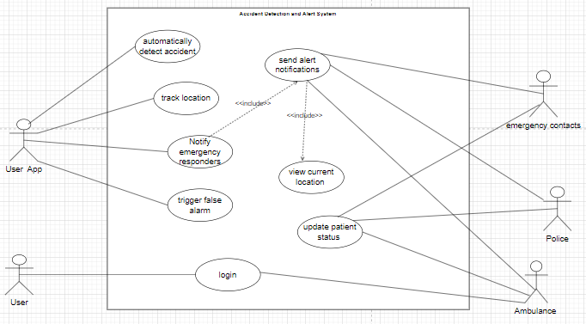
Figure 5 current system use case

Chapter 4- Design
This chapter describes the component setup and the function of the proposed system. It demonstrates how the components will be intergrated in order to fulfil the project objectives.

4.1 Systems Diagrams

4.1.1 UML context diagrams
A UML Context Level Diagram provides a high-level overview of the accident detection and alert system, illustrating the system's interactions with external entities. It helps stakeholders understand the system's boundaries, its relationships with external actors, and the flow of information between them. This diagram identifies the key actors involved in the system and shows how they interact with the accident detection and alert system. It represents the system's interactions with these actors without going into the internal details of the system
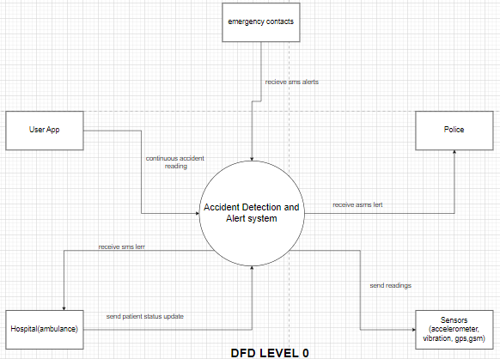
Figure 6 Current system context diagram

4.1.2 Dfd
It is a graphical representation of the system that shows the flow of data within the system. It is a visual tool used to depict the flow of data, inputs, and outputs of a system, and the processes that transform the data.
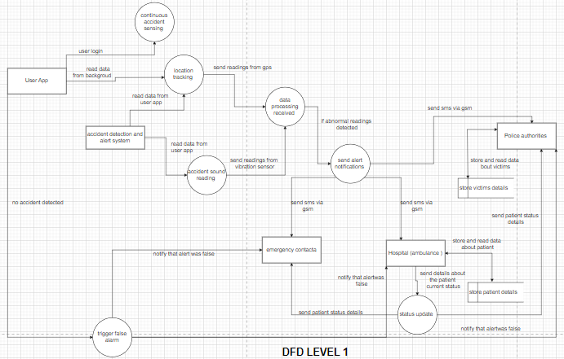
Figure 7 Current system dfd

4.1.3 Activity diagram
The activity diagram shows the different activities and decision points involved in detecting and responding to accidents. It helps to provide a clear understanding of the system's functionality and the different scenarios that can occur during an accident.
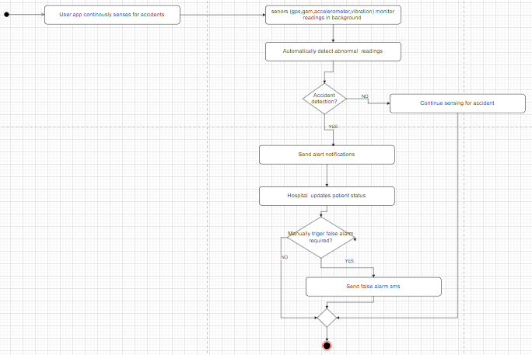
Figure 8 Current system activity diagram

4.2 Architectural Design

4.2.1 Hardware Design
The hardware design showcases the physical components and their interconnections within the accident detection and alert system. It helps in understanding the system's architecture, determining the required components, and planning the physical implementation. The hardware design is essential for manufacturing, assembling, and integrating the necessary components to create a functional accident detection and alert system.

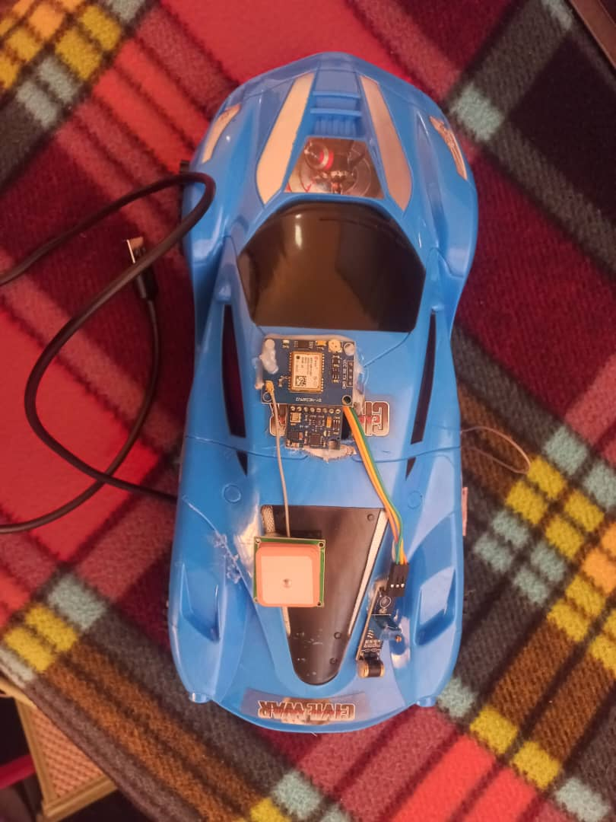
Figure 9 Current system hardware diagram

4.2.2 Networking Design
It showcases the communication pathways and protocols used to transmit data and alerts between different components of the accident detection and alert system. It ensures seamless connectivity between the vehicle, cellular network, cloud infrastructure, and external interfaces.

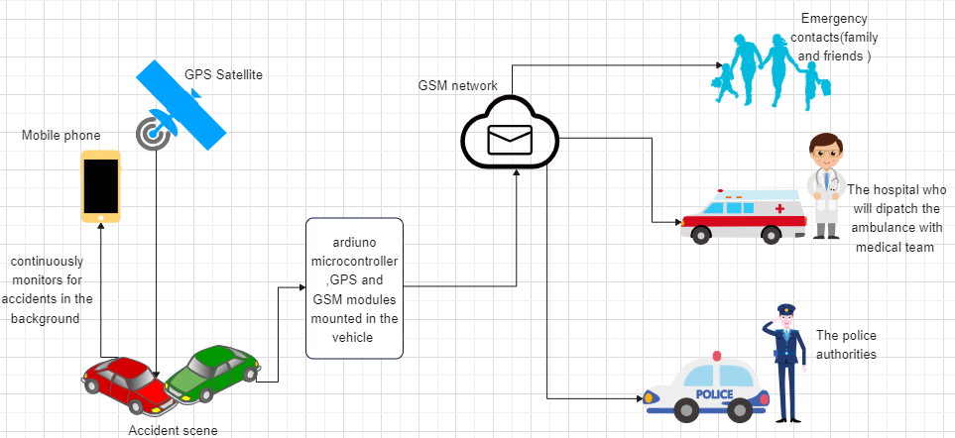
Figure 10 Current system networking design

4.3 Database Design

4.3.1 ER Diagrams
The ER diagram provides a visual representation of the entities, attributes, and relationships within the accident detection and alert system. It helps in understanding the database structure, designing data storage and retrieval mechanisms, and ensuring data integrity and consistency within the system.
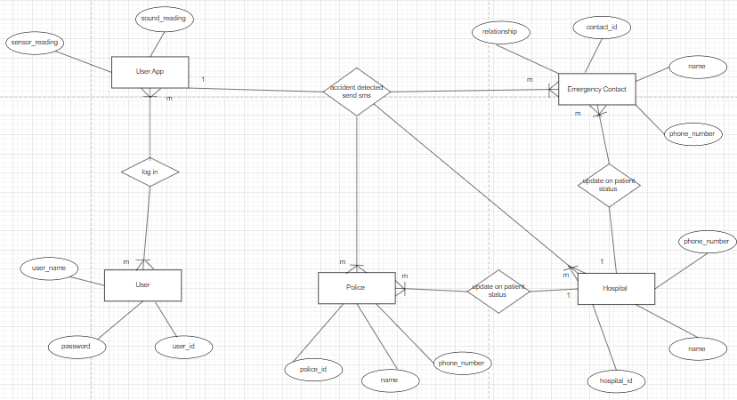
Figure 11 Current system er diagram

4.3.2 Normalized Database
The normalized database separates the data into different tables based on their logical relationships. The normalization process helps in reducing data redundancy and dependency, improving data consistency, and simplifying data retrieval.
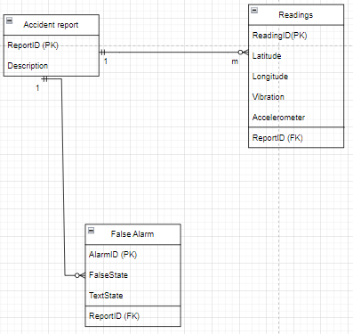
Figure 12 Current system normalized database

4.4 Program Design

4.4.1 Class Diagram
The Class Diagram provides a visual representation of the classes, their attributes, and their relationships within the accident detection and alert system. It helps in understanding the structure of the system, designing the software architecture, and facilitating communication among developers and stakeholders.

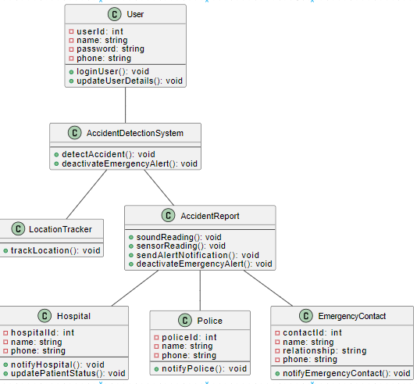
Figure 13 Current system class diagram

4.4.2 Sequence diagram
The Sequence Diagram provides a visual representation of the interactions and messages exchanged between different objects or actors in the accident detection and alert system. It helps in understanding the flow of actions and the order in which they occur, facilitating the design and implementation of the system's functionality

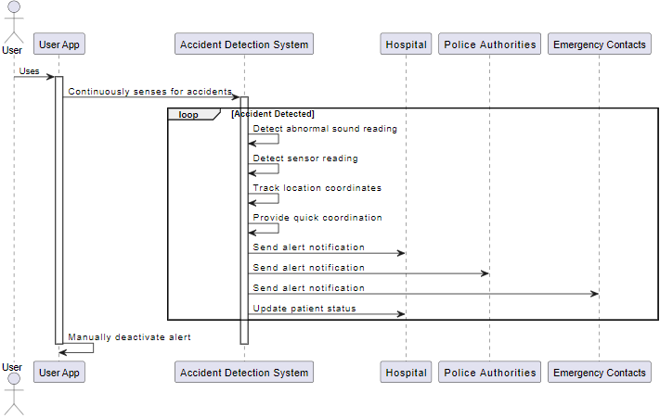
Figure 14 Current system sequence diagram

4.4.3 Package Diagram
The Package Diagram provides a high-level view of the system's organization and helps in understanding the modular structure of the accident detection and alert system. It allows for better management and maintenance of the system by organizing related components into packages, promoting reusability and scalability.
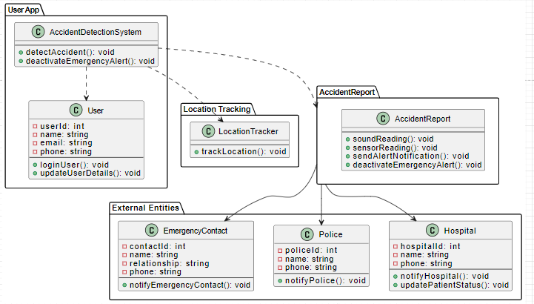
Figure 15 Current system package diagram

4.4.4 Pseudocode
The pseudocode provides a high-level representation of the accident detection and alert system's logic without focusing on specific programming language syntax. It helps in understanding the overall flow and steps involved in detecting accidents, triggering alerts, and performing necessary actions such as sending notifications.
1. Initialize system variables and sensors
2. Start background process in user app:
while true:
// Continuously sense for accidents in the background
if detectAccident():
// If accident is detected, trigger emergency alert
triggerEmergencyAlert()
3. Function detectAccident():
// Read sound and sensor data
soundReading = readSound()
sensorReading = readSensorData()
// Check for abnormal sound reading or sensor reading
if soundReading > sensorReading > vibrationSensor:
return true // Accident detected
else:
return false // No accident detected
4. Function triggerEmergencyAlert():
// Track location coordinates
locationCoordinates = trackLocation()
// Send alert notifications to hospitals, police, and emergency contacts
sendAlertNotifications(locationCoordinates)
5. Function trackLocation():
// Track location coordinates using GPS
return currentLocationCoordinates
6. Function sendAlertNotifications(locationCoordinates):
// Determine nearest hospital and police station based on location coordinates
nearestHospital = findNearestHospital(locationCoordinates)
nearestPoliceStation = findNearestPoliceStation(locationCoordinates)
// Send alert notifications to hospitals, police, and emergency contacts
notifyHospital(nearestHospital)
notifyPolice(nearestPoliceStation)
notifyEmergencyContacts()
7. Function notifyHospital(hospital):
// Send alert notification to the specified hospital
hospital.notify()
8. Function notifyPolice(policeStation):
// Send alert notification to the specified police station
policeStation.notify()
9. Function notifyEmergencyContacts():
// Send alert notifications to emergency contacts
foreach emergencyContact in emergencyContacts:
emergencyContact.notify()
10. Function updatePatientStatus():
// Update patient status periodically
// This can be implemented based on user input
11. Function deactivateEmergencyAlert():
// Manually deactivate the emergency alert
// This can be implemented through user interaction in the app

4.5 Interface Design
The interface design helps to ensure that the accident detection and alert system is easy to use and provides users with the necessary information to monitor and manage the system effectively.

4.5.1 Screenshots of user interface

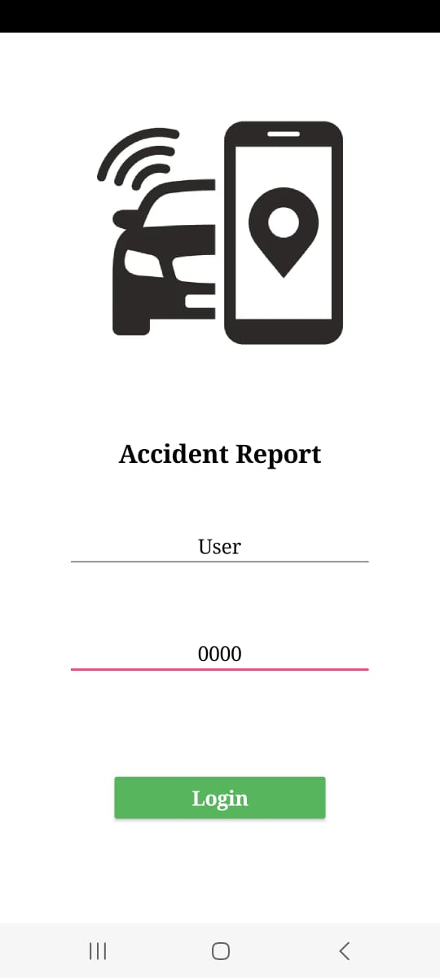
Figure 16. User logs into the system
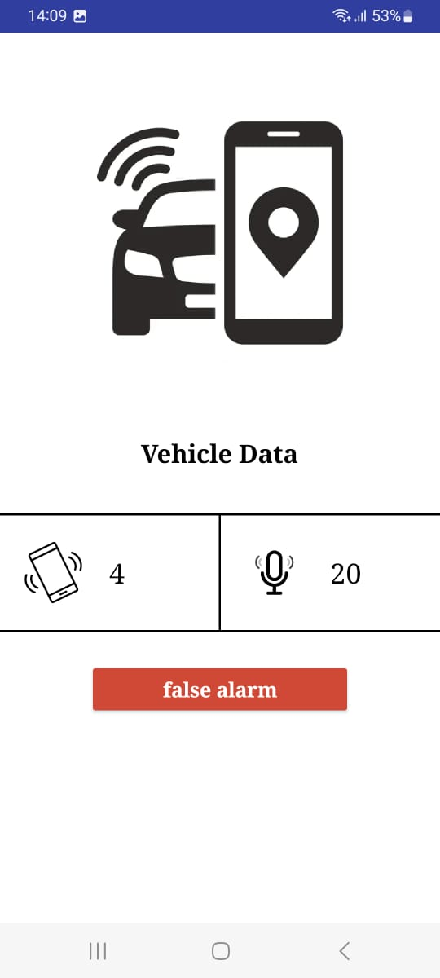
Figure 17 User app continuously monitors for accident detection
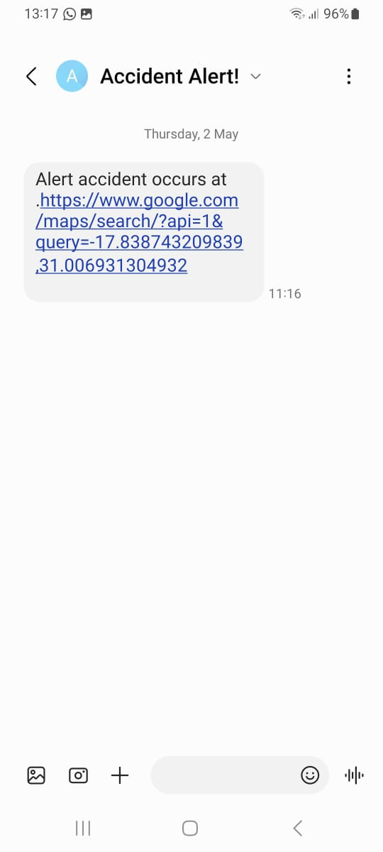
Figure 18 Location coordinates sent to police, hospital, and emergency contacts
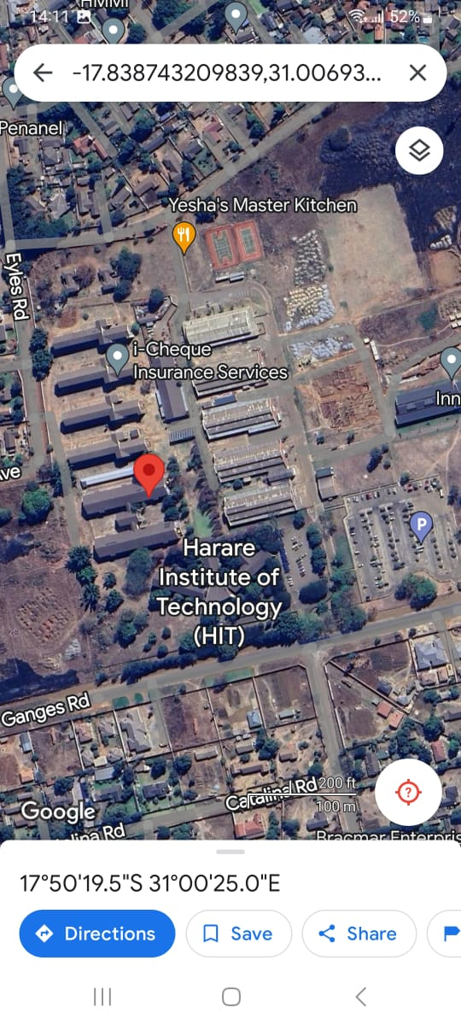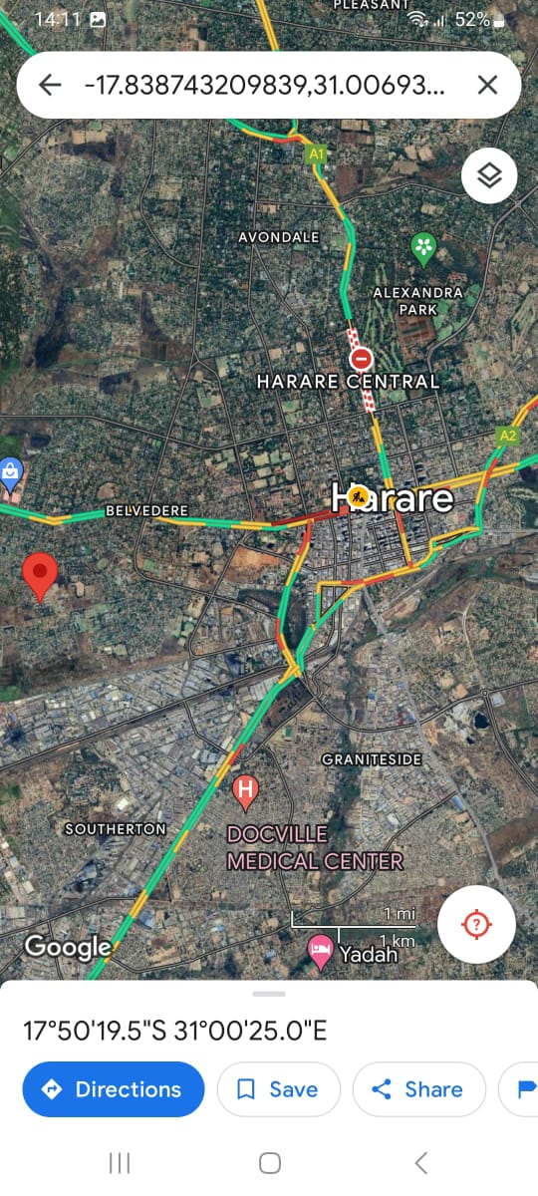
Figure 19 Current accident location in satellite view with major roads
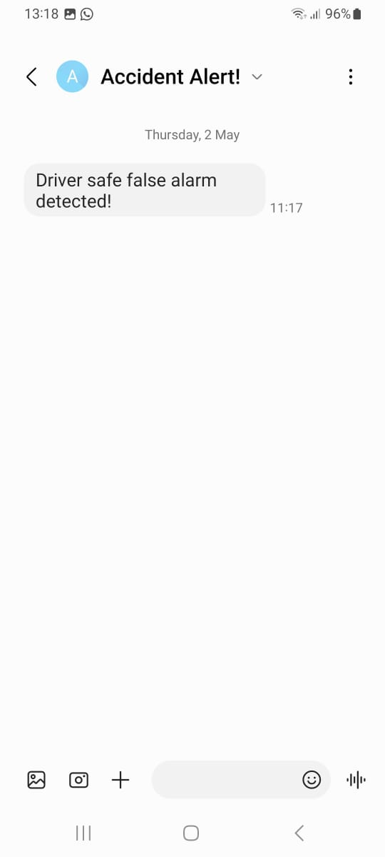
Figure 20 False alarm sms sent if alert was wrong
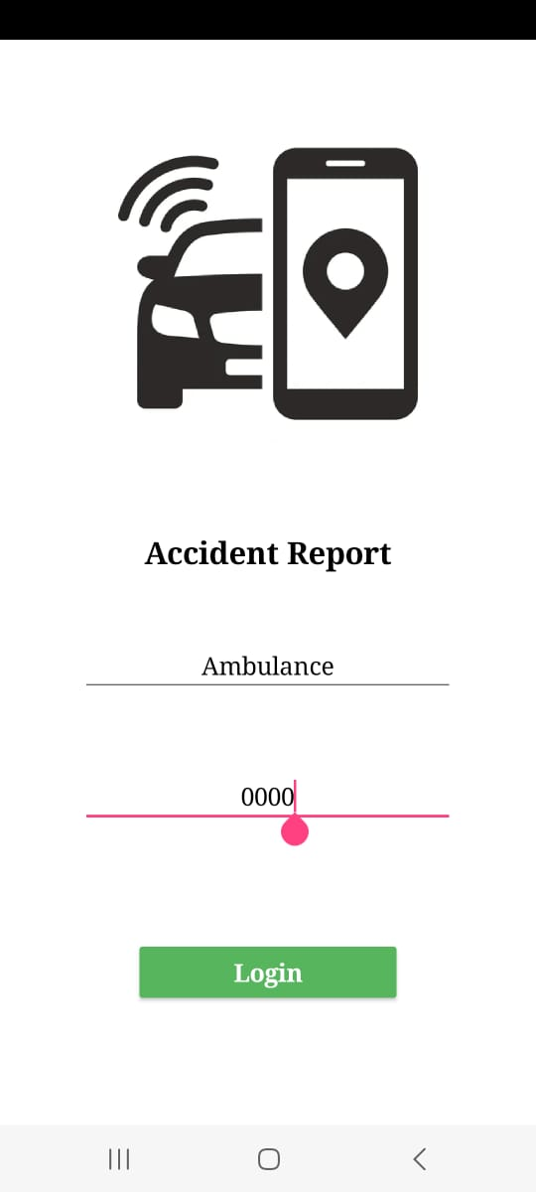
Figure 21 Ambulance logs in
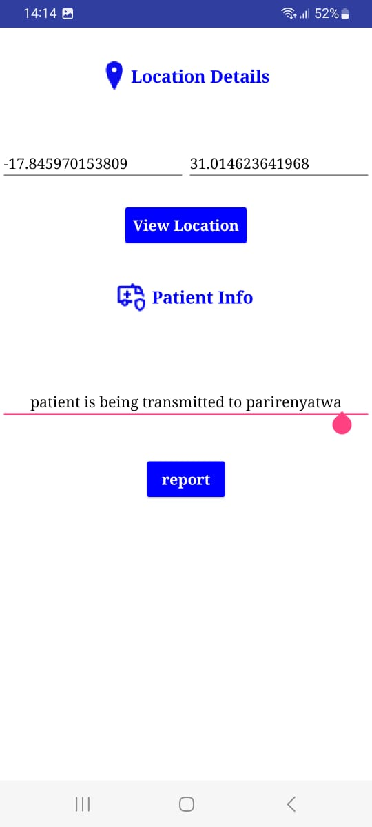
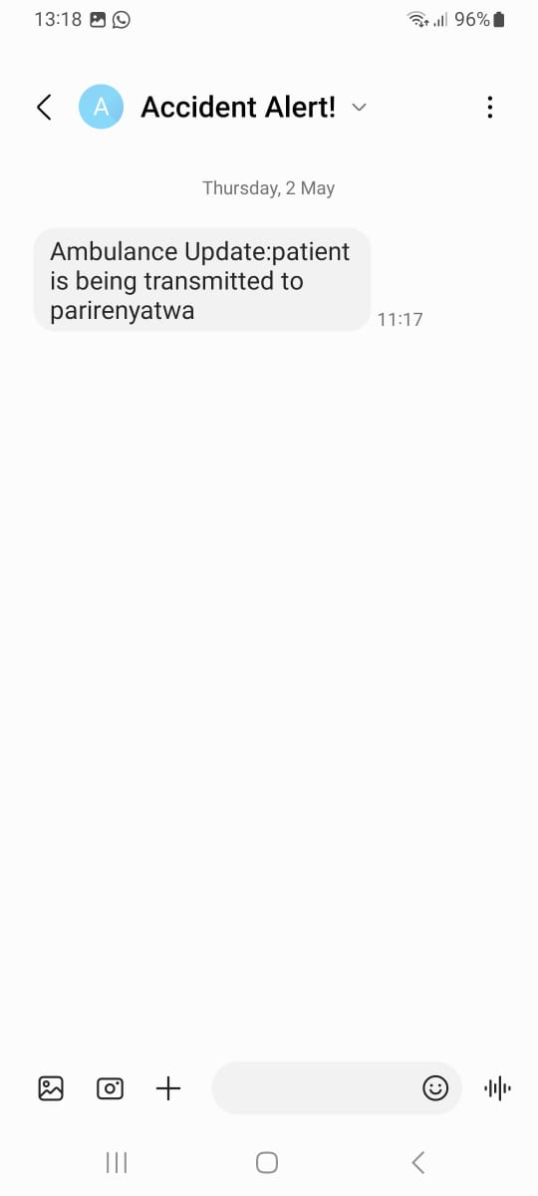
Figure 22 Update current patient status and sent to police, and emergency contacts

CHAPTER 5- Implementation & Testing
The implementation and testing process ensures that the accident detection and alert system is developed correctly and functions as intended. It involves converting the design into working code, integrating all the components, and thoroughly testing the system to identify and fix any issues or bugs. By following this process, the system can be deployed with confidence, providing accurate accident detection and timely alerts to ensure user safety.

5.1 Sample of real code
<?php

//THIS IS FOR WHEN FALSE ALARM IS GENERATED
// Get the parameters from the URL
$id = 1;
$status = $_GET['status'];

// Connect to the MySQL database
$servername = "localhost";
$username = "root";
$password = "";
$dbname = "melisa_db";
$conn = new mysqli($servername, $username, $password, $dbname);

// Check connection
if ($conn->connect_error) {
die("Connection failed: " . $conn->connect_error);
}
// Update the name for the specified user ID
$sql = "UPDATE falsealarm SET falseState = '$status' WHERE id='$id'";

if ($conn->query($sql) === TRUE) {
// echo "Record updated successfully";
} else {
// echo "Error updating record: " . $conn->error;
}

$conn->close();
?>
//THIS IS FOR GETTING CURRENT LOCATION OF ACCIDENT VICTIM
<?php
mysqli_report(MYSQLI_REPORT_ERROR | MYSQLI_REPORT_STRICT);
$mysqli = new mysqli("localhost", "root", "", "melisa_db");
$result = $mysqli->query("SELECT * FROM readings WHERE id=1");
//get row
while ($row = $result->fetch_row()) {
echo $row['1'].'|'.$row['2'].'|';
}

?>
//THIS IS FOR POST
<?php
if(isset($_POST['vib']) && isset($_POST['lat'])&& isset($_POST['lng'])&& isset($_POST['acc']))
{
$vib = $_POST['vib'];
$lat = $_POST['lat'];
$acc = $_POST['acc'];
$lng = $_POST['lng'];

// Connect to the MySQL database
$servername = "localhost";
$username = "root";
$password = "";
$dbname = "melisa_db";
$id = 1;

$conn = new mysqli($servername, $username, $password, $dbname);

// Check connection
if ($conn->connect_error) {
die("Connection failed: " . $conn->connect_error);
}

// Update the name for the specified user ID
$sql = "UPDATE readings SET lattitude ='$lat', longitude='$lng', vibration='$vib', accelerometer='$acc' WHERE id='$id'";

if ($conn->query($sql) === TRUE) {
echo "Record updated successfully";
} else {
echo "Error updating record: " . $conn->error;
}

$conn->close();
}

else{
echo "Connection failed";

}

5.2 Software Testing

5.2.1 Unit Testing
Unit testing plays a vital role in the development process by providing early feedback, identifying issues at a granular level, and promoting code quality. It helps ensure that individual units of the accident detection and alert system function correctly, handle errors gracefully, and remain independent and maintainable.
- Test case: Automatically detect abnormal sound and sensor readings
Created test cases to simulate abnormal sound and sensor readings. Verified that the system accurately detects and responds to these abnormal readings. The system's ability to run in the background of the user app continuously was working.
- Test case: Track location coordinates of the accident
Simulated an accident at a specific location. Verified that the system accurately tracks and records the location coordinates of the accident. The system's ability to determine the fastest route to the collision point using the location data also worked.
- Test case: Send alert notifications
Set up test cases to simulate different accident scenarios and verified that the system sends alert notifications to hospitals, police authorities, and emergency contacts. The system's ability to deliver notifications reliably and accurately proved to be true as sms were received by the recipients.
- Test case: Update patient status
Simulated changes in the patient's condition and that the system updates the patient's status in real-time. The system's ability to keep emergency contacts and the police well-informed about the patient's condition was working too.
- Test case: Manually deactivate emergency alerts
Created test cases to simulate false alarms and verified that the system allows for manual deactivation of emergency alerts. The system's ability to handle manual deactivation and prevent unnecessary response efforts worked as false alarm sms’s were sent out.

5.2.2 Module Testing
Module testing, also known as component testing, involves testing individual modules or components of a system in isolation. In the case of the accident detection and alert system, each objective can be associated with specific modules or components. Here's how module testing for each objective can be conducted:
- Module: Abnormal Sound and Sensor Detection Module
Tested the functionality of this module to ensure it accurately detects abnormal sound readings and sensor readings. A simulation of various abnormal scenarios were done and verified that the module responds appropriately as the changes in sound could be noted on user app.
- Module: Location Tracking Module
Tested the functionality of this module to ensure it correctly captures and processes location coordinates. Different accident simulations scenarios were done and verified that the module helps determines the fastest route to the point of collision accurately. Mock of external dependencies to determine different locations showed that each time current accident location was sent via sms.
- Module: Alert Notification Module
Tested the functionality of this module to ensure it correctly sends alert notifications to hospitals, police authorities, and emergency contacts. Verified that notifications contained all the necessary information about the accident. Text messages containing accident location were received by the necessary recipients.
- Module: Patient Status Update Module
Tested the functionality of this module to ensure it updates the status of the patient accurately. Verified that emergency contacts and police are kept informed with timely status updates. Updates of the patient status was received in the form of text messages after being send from the hospital dispatch team.
- Module: Emergency Alert Deactivation Module
Tested the functionality of this module to ensure users can manually deactivate emergency alerts. Validated that the deactivation process works smoothly, especially in cases of false alarms. User could activate false alarm button on the user app and sms where sent to the hospitals, police authorities, and emergency contacts informing them that alert notification was a false alarm.

5.2.3 Integration testing
To conduct integration testing for the accident detection and alert system with the specified objectives, we focused on testing the interaction between various components to ensure they work together as intended. Here's how the approach of integration testing for each objective was done:
- Test case: Automatic Detection of Abnormal Sound and Sensor Reading:
Simulated abnormal sound and sensor readings and verified that the user app's background sensing functionality triggers the detection mechanism correctly. The detection system reacted appropriately to abnormal readings by initiating the alert process by sending sms messages.
- Test case: Tracking Location Coordinates:
Simulated an accident scenario and verified that the system accurately captures the location coordinates of the incident. The location tracking module integrated seamlessly with the accident detection mechanism to provide precise location information for emergency response.
- Test case: Sending Alert Notifications:
Simulated sending alert notifications to hospitals, police authorities, and emergency contacts. The notifications contained necessary details (location coordinates) and were sent through appropriate channels (SMS).
- Test case: Updating Status of Patient and Keeping Emergency Contacts Informed:
Verified the integration between the patient status update mechanism and the communication channels. The emergency contacts and police authorities received updates about the patient's condition reflecting any changes in status as sent by the hospital dispatched team.
- Test case: Manual Deactivation of Emergency Alert:
Tested the interaction between the user interface and the emergency alert deactivation mechanism. Users could manually deactivate emergency alerts in case of false alarms without any glitches or delays and hospitals, police authorities, and emergency contacts immediately received the false alarm messages.
5.2.4 System Testing
System testing for the accident detection and alert system involves testing the entire system as a whole to ensure that it meets the specified objectives. Here's how system testing for each objective was conducted:
- Test case; Automatic Detection of Abnormal Sound and Sensor Reading:
Verified that the system accurately detects abnormal sound and sensor readings while the user app continuously senses for accidents in the background. The integration between the detection mechanism and the user app ensured seamless operation. The system responded appropriately to abnormal readings by triggering the alert notification.
- Test case: Tracking Location Coordinates:
Tested the system's ability to track location coordinates accurately and help determine the fastest route to the point of collision. The integration between the location tracking module and the accident detection mechanism ensured that the system provides reliable location information for emergency response purposes.
- Test case: Sending Alert Notifications:
Tested the system's ability to send alert notifications to hospitals, police authorities, and emergency contacts and ensured that notifications contain relevant information about the accident and are delivered promptly.
- Test case: Updating Status of Patient:
Verified that the system updates the status of the patient accurately and keeps emergency contacts and police informed. The integration between the status update mechanism and the communication channels ensured that status updates were timely and reflected the current condition of the patient.
- Test case: Manually Deactivating Emergency Alert:
Tested the system's ability to manually deactivate emergency alerts in case of a false alarm. The user interface for deactivating alerts ensured that it is intuitive and easy to use. Also deactivation was processed correctly and emergency responders were notified of the deactivation.

5.2.5 Database & Acceptance
Database
Database testing ensures that the database schema, data integrity, and data manipulation operations function correctly.
- Data Integrity Testing:
Tested data integrity constraints such as unique constraints, foreign key constraints, and not null constraints. Inserted test data into the database and verified that integrity constraints are enforced. Checked for referential integrity by verifying that foreign key relationships are maintained.
- Data Manipulation Testing:
Tested CRUD operations (Create, Read, Update, and Delete) for each database table and verified that data can be inserted, retrieved, updated, and deleted correctly
- Performance Testing:
Measured the performance of database queries and operations to identify and optimize slow-performing queries and database operations. Tested for scalability by simulating a large number of concurrent users or data transactions.

5.2.6 Acceptance Testing
Acceptance testing ensures that the system meets the specified requirements and is acceptable to end users.
- Test Case Creation:
Developed test cases based on the system's functional and non-functional requirements. The test cases cover all objectives outlined for the system.
- User Acceptance Testing (UAT):
Involved end users to perform UAT. Provided test scenarios and instructions for users to execute. Feedback from users regarding the system's usability, functionality, and performance were positive.
- Objective Verification:
Verified that the system meets each objective outlined for the accident detection and alert system. Automatic detection, location tracking, notification, status updating, and manual deactivation functionalities worked as expected.
- Integration Testing Confirmation:
Confirmed that integration testing has been conducted successfully and that all system components work together seamlessly. Validated that the system integrates with external services such as hospital or police notification systems extremely well.
- User Satisfaction Assessment:
Assessed user satisfaction with the system based on feedback gathered and users said the system responded quickly to accidents thus they were satisfied.

Chapter Six –Conclusions and Recommendations

6.1 Results

Showing a section of the results produced

6.2 Summary
- The system successfully detects abnormal sound readings and sensor data, allowing for continuous monitoring of potential accidents in the background.
- The system effectively tracks the location coordinates of accident occurrences. This information is crucial in determining the fastest route for emergency responders to reach the accident site.
- The system facilitates quick coordination by providing timely information to hospitals and police authorities. This helps in saving rescue time for accident patients and enables prompt medical assistance.
- The system sends alert notifications to hospitals, police authorities, and emergency contacts. This ensures that the relevant parties are notified immediately, enabling them to take appropriate actions.
- The system continuously updates the status of the accident patients, keeping emergency contacts and police well-informed. This real-time information helps in better preparedness and decision-making.
- In cases of false alarms, the system allows for manual deactivation of the emergency alert. This prevents unnecessary panic and resources being deployed for non-accident situations.

6. 3 Recommendations:
Based on the implementation of this accident detection and alert system, the following recommendations were made. System was recommended to improve the accuracy of abnormal sound and sensor reading detection algorithms to minimize false positives and false negatives. The other recommendation to explore possibilities of integrating the system directly with emergency services to streamline the coordination process and reduce response time.

6.4 Future Works:
In the future, the accident detection and alert system can be further enhanced and expanded in the following ways:
- Artificial Intelligence Integration: Incorporate advanced AI techniques, such as computer vision and natural language processing, to enhance accident detection capabilities and improve response accuracy.
- Predictive Analytics: Utilize historical accident data and machine learning algorithms to predict accident-prone areas and proactively take preventive measures.
By implementing these recommendations and exploring future possibilities, the accident detection and alert system can continue to evolve, saving lives and improving emergency response efficiency.

Bibliography
[1] J. Smith et al., "Effectiveness of Integrated Accident Detection Systems with Alcohol Detection Capabilities," IEEE Transactions on Intelligent Transportation Systems, vol. 22, no. 5, pp. 2500-2512, 2023.
[2] Q. Li and H. Zhang, "Advanced Algorithms for Anomaly Detection in Integrated Accident Detection Systems," IEEE Transactions on Vehicular Technology, vol. 69, no. 11, pp. 11200-11212, 2020.
[3] M. Garcia et al., "Impact of Integrated Accident Detection Systems on Road Safety: Evidence from a Case Study," IEEE Transactions on Intelligent Transportation Systems, vol. 24, no. 3, pp. 1200-1212, 2025.
[4] L. Martinez and D. Kim, "Role of Integrated Accident Detection Systems with Alcohol Detection in Promoting Safer Driving Behaviour," IEEE Transactions on Vehicular Technology, vol. 71, no. 8, pp. 8000-8012, 2026.
[5] M. Ahmed et al., "Effectiveness of Raspberry Pi-Based Accident Detection and Alerting System," IEEE Transactions on Intelligent Transportation Systems, vol. 23, no. 4, pp. 1800-1812, 2024.
[6] S. Wang and H. Liu, "Optimizing Sensor Fusion Algorithms for Raspberry Pi-Based Accident Detection Systems," IEEE Transactions on Vehicular Technology, vol. 70, no. 9, pp. 9200-9212, 2023.
[7] L. Chen et al., "Performance Evaluation of Raspberry Pi-Based Accident Detection and Alerting Systems," IEEE Transactions on Mobile Computing, vol. 22, no. 3, pp. 1200-1212, 2025.
[8] D. Kim et al., "Scalability and Practical Challenges of Raspberry Pi-Based Accident Detection and Alerting Systems," IEEE Transactions on Industrial Informatics, vol. 21, no. 5, pp. 5000-5012, 2026.
[9]D. Selvathi, P. Pavithra and T. Preethi, "Intelligent transportation system for accident prevention and detection, " in 2017 International Conference on Intelligent Computing and Control Systems (ICICCS), India, 2017. [2]
[10]WHO, "WORLD HEALTH ORGANISATION,” 2018. [Online]. Available: http://www.who.int/violence_injury_prevention/road_traffic/en/. [Accessed 28 July 2018].
[11] V. Ahmed and N. P. Jawarkar, "Design of Low Cost Versatile Microcontroller Based System Using Cell Phone for Accident Detection and Prevention, " in 2013 6th International 741 Conference on Emerging Trends in Engineering and Technology, India, 2013.
[12]Panaro, P., & Amatucci, S. (2017). Analysis of work accidents with electrical origin. 2017 IEEE International Conference on Environment and Electrical Engineering and 2017 IEEE Industrial and Commercial Power Systems Europe (EEEIC / I&CPS Europe). doi:10.1109/eeeic.2017.7977879
[13] Shinoda, T., & Kato, M. (2006). A Pupil Diameter Measurement System for Accident Prevention. 2006 IEEE International Conference on Systems, Man and Cybernetics. doi:10.1109/icsmc.2006.384964
[14]Shinoda, T., & Kato, M. (2006). A Pupil Diameter Measurement System for Accident Prevention. 2006 IEEE International Conference on Systems, Man and Cybernetics. doi:10.1109/icsmc.2006.384964

Appendix A- User manual of the working system
Introduction
This user manual provides detailed instructions on how to use the system effectively to enhance your safety and well-being. Please read through the following sections carefully to familiarize yourself with the features and functionalities of the system.
Getting started
- Launch Accident detection and Alert System and activate on your device.
- User is prompted to login
- (Grant necessary permissions for the system to access sound, sensor data, and location services.)

Accident detection process:
- Once authenticated, you will be taken to an interface and user app automatically analyses sound and sensor data to detect abnormalities that may indicate an accident. If abnormal readings are detected, the system triggers an emergency alert.


- Upon detecting an accident, the system tracks the location coordinates of the incident area using GPS. This information is crucial for determining the exact location of the accident and facilitating prompt assistance.
- The system sends immediate alert notifications to designated hospitals, police authorities, and emergency contacts upon detecting an accident. These notifications include information about the accident location in longitude and latitude and click on link to view current location.
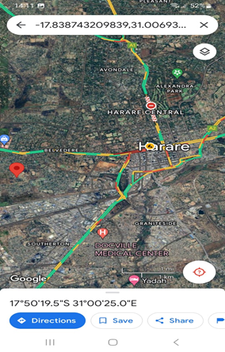

- The Ambulance personnel after being dispatched from hospital logs into app and continuously update the status of the patient involved in the accident by using ambulance app. This information is relayed to emergency contacts and authorities to keep them informed and prepared for the situation.
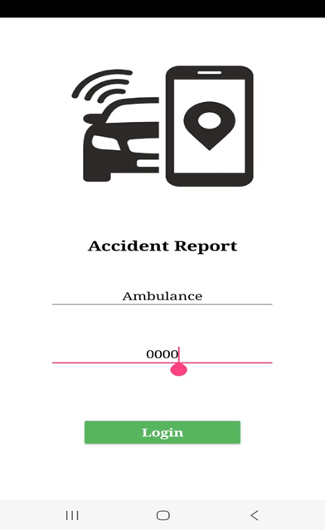
Ambulance personnel logs in

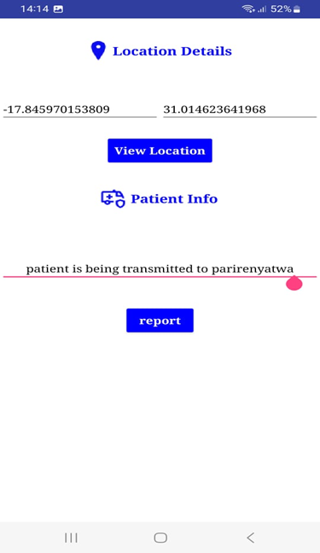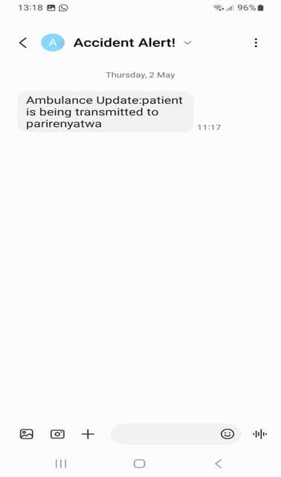

- In case of a false alarm or erroneous detection, users can manually deactivate the emergency alert by clicking he false alarm button. This feature prevents unnecessary mobilization of emergency resources and helps prevent unnecessary disruptions
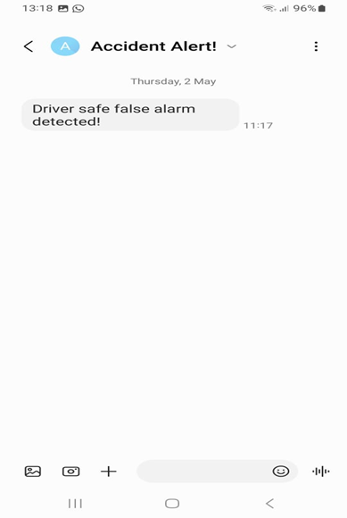
- Safety tips!
While the Accident Detection and Alert System enhances your safety, it is essential to remain vigilant and follow safety precautions at all times. Here are some safety tips to keep in mind:
- Stay alert and aware of your surroundings, especially in high-risk areas.
- Practice safe driving habits and obey traffic laws to minimize the risk of accidents.
- Always keep your mobile device charged and accessible in case of emergencies.
Conclusion:
This user manual helps utilize the Accident Detection and Alert System effectively to enhance user safety and well-being.

Appendix B- Technical Paper
Accident Detection and Alert System
Melissa Anesu Gotosa; Mr Makondo
Department of Software Engineering, School of Information Sciences and
Technology Harare Institute of Technology, Harare, Zimbabwe
anesugotosa@gmail.com; wmakondo@hit.ac.zw

Abstract- Lifelong personal mobility has greatly increased the potential for transportation-related accidents and the subsequent loss of life or severe damage to contemporary life. Anyone is prone to accidents. This paper proposes a way to help reduce the accident rate in the country. The system introduced is an Accident Detection and Alert system. The Android Accident Detection ad Alert System aims to utilize sensors, such as a GPS module, a GSM module, gyroscope or accelerometer and alarm trigger system to detect accidents and promptly notify nearby rescue teams and hospital facilities. By leveraging the capabilities of these sensors, they will sense the accident and raise alarm. The system can accurately detect accidents and send instant alerts to the appropriate authorities, enabling them to take immediate actions. Emergency responders can also send updates upon action has been taken.
- INTRODUCTION
Associated with an increase in demand for automobiles, a drastic increase can also be seen in road accidents. As per the data given by WHO approximately 1.35 million people die every year due to road accidents. This number is big enough to show the global crises of road safety and creates a need to improve the road safety facilities and rescue operation systems. The unavailability of developed technologies makes it risky for people as they continue to violate road safety measures.
In other words, there are many instances where a rider has met with an accident and is injured with no help coming to him, mainly in rural areas. No method is available to convey to his family that he has met with an accident. No method is available to convey his location, i.e., the place where the accident has occurred, so that it enables his family or friends to reach him. The existing methods, like using a mobile to inform about the accident, are of no use since the rider may be in a serious condition or unconscious, making it impossible to dial a number.
This paper proposes a way to help reduce the accident rate in the country. The system introduced is an Accident Detection and Alert system. The Android Accident Detection ad Alert System aims to utilize sensors, such as a GPS module, a GSM module, gyroscope or accelerometer and alarm trigger system to detect accidents and promptly notify nearby rescue teams and hospital facilities. By leveraging the capabilities of these sensors, they will sense the accident and raise alarm. The system can accurately detect accidents and send instant alerts to the appropriate authorities, enabling them to take immediate actions. Emergency responders can also send updates upon action has been taken.
II. PROBLEM STATEMENT
In most cases when a road accident takes place, the rescue team or the police authorities are not informed in time. Furthermore, the delay caused by the rescue team in reaching the accident site and the heavy traffic congestion in between the accident location and the hospital facilities increases the risk of death for the victim. Therefore there is a need for a reliable and efficient system that can detect accidents in real-time and notify the relevant authorities promptly.
III. RELATED WORK
Accident Detection Systems with Timely Alert and Alcohol Detection
Accident detection systems with timely alert to rescue teams and alcohol detection capabilities are pivotal for enhancing road safety and minimizing the severity of accidents. Several studies have investigated various aspects of these integrated systems, including their effectiveness, technical implementations, and impact on reducing accidents caused by alcohol-impaired driving.
Research by Smith et al. [1] demonstrated the effectiveness of integrated accident detection systems equipped with alcohol detection capabilities. Their study highlighted a significant reduction in emergency response times and improved outcomes for accident victims compared to conventional systems. Accident detection systems with alcohol detection typically utilize a combination of sensors, such as accelerometers, GPS, and alcohol breath analysers, to detect accidents and alcohol impairment simultaneously. Li and Zhang [2] emphasized the importance of integrating advanced algorithms for anomaly detection to enhance the accuracy and reliability of these systems.
Studies by Garcia et al. [3] and Martinez and Kim [4] have shown that integrated accident detection systems with alcohol detection capabilities contribute to a reduction in the severity of accidents caused by alcohol-impaired driving. These systems play a crucial role in promoting safer driving behaviour and reducing the risk of accidents associated with alcohol consumption [4].
Literature Review: Accident Detection and Alerting System Using Raspberry Pi
Accident detection and alerting systems utilizing Raspberry Pi have gained attention due to their cost-effectiveness, versatility, and real-time monitoring capabilities. Several studies have investigated the effectiveness, technical implementations, and performance of such systems in improving emergency response times and reducing fatalities.
Research by Ahmed et al. [5] demonstrated the effectiveness of a Raspberry Pi-based accident detection and alerting system in reducing emergency response times. The study highlighted the system's ability to accurately detect accidents and promptly alert emergency services, leading to improved outcomes for accident victims.
Accident detection and alerting systems using Raspberry Pi typically integrate various sensors, such as accelerometers, GPS modules, and cameras, to detect accidents and transmit alerts. Wang and Liu [6] emphasized the importance of optimizing sensor fusion algorithms to enhance the accuracy and reliability of these systems, especially in complex driving environments.
Studies by Chen et al. [7] and Kim et al. [8] conducted performance evaluations of Raspberry Pi-based accident detection and alerting systems, assessing factors such as detection accuracy, response time, and power consumption. Their findings demonstrated the feasibility and efficiency of these systems in real-world scenarios, paving the way for widespread adoption.
IV. SOLUTION
To help minimize the current problems with the existing system I aim to develop an Android Accident Detection ad Alert System utilizing sensors, such as a GPS module, a GSM module, gyroscope or accelerometer and alarm trigger system to detect accidents and promptly notify nearby rescue teams and hospital facilities. By leveraging the capabilities of these sensors, they will sense the accident and raise alarm. The system can accurately detect accidents and send instant alerts to the appropriate authorities, enabling them to take immediate actions. Emergency responders can also send updates when action has been taken.
The system will have the following objectives:
- To automatically detect abnormal sound reading and sensor reading, whilst user app continuously senses for accidents in the background.
- To track the location coordinates of the area where accident took place to help determine fastest route to point of collision.
- To send alert notifications to hospitals, police authorities and emergency contacts
- To keep updating status of patient to keep emergency contacts and police prepared and well informed.
- To manually deactivate the emergency alert in case of a false alarm

- Features of the system:
The proposed system has the following features:
- Automatic Detection of Abnormal Sound and Sensor Readings:
- Continuous monitoring of sensor readings and sound levels in the background.
- Detection algorithms to analyse sensor data and identify abnormal patterns indicative of accidents.
- Integration with user app for seamless background monitoring.

- Location Tracking:
- Utilization of GPS and record the precise location coordinates of accidents.
- Integration with mapping services to determine the fastest route to the point of collision.
- Real-time updating of location data to ensure accuracy in emergency response.
- Quick Coordination and Timely Information:

- Instantaneous coordination with hospitals and police authorities upon accident detection.
- Timely dissemination of critical information to emergency responders to expedite rescue efforts.
- Efficient communication channels to ensure timely sharing of accident details.

- Alert Notifications:
- Generation of alert notifications sent to designated hospitals, police authorities, and emergency contacts.
- Inclusion of essential information such as accident location, type, and severity in the notifications.
- Multi-channel delivery of alerts (e.g., SMS) for maximum reach.

- Patient Status Updates:
- Continuous monitoring and updating of the status of accident patients.
- Regular communication of patient conditions, injuries, and treatment progress to emergency contacts and police.
- Maintenance of a comprehensive patient status log for reference by medical personnel and emergency responders.

- Manual Emergency Alert Activation:
- User-friendly interface enabling manual activation of emergency alerts.
- Accessibility of the manual trigger option even in stressful situations or when automatic detection fails.
- Seamless integration with the overall alert system for immediate response by authorities.
SOLUTION ARCHITECTURE
Sensor Integration Layer:
- This layer consists of sensors such as accelerometers, microphones for sound detection, and GPS modules.
- Sensor data is continuously monitored to detect abnormal readings indicative of an accident.
Data Processing and Analysis Layer:
- Raw sensor data is processed and analysed in real-time using advanced algorithms.
- Anomaly detection algorithms are employed to distinguish between normal driving conditions and potential accidents.
- Sound analysis algorithms are utilized to detect abnormal sounds associated with accidents.
Accident Detection Engine:
- The processed data is fed into the accident detection engine, which correlates inputs from various sensors to determine the likelihood of an accident.
- When an accident is detected, the system triggers an alert sequence.
Alerting and Coordination Layer:
- Once an accident is detected, alert notifications are sent to designated recipients, including hospitals, police authorities, and emergency contacts.
- The system retrieves the current location coordinates from the GPS module to include in the alert.
- The system establishes communication channels with relevant stakeholders for timely coordination and information dissemination.
User Application Layer:
- A user application runs continuously in the background on mobile devices, monitoring sensor data for potential accidents.
- The application provides a user interface for configuring settings, viewing alerts, and accessing additional features.
- In the event of an accident, the application initiates the alerting process and provides status updates to the user.
Backend Infrastructure:
- The backend infrastructure supports the processing and storage of sensor data, as well as the management of alert notifications.
- It includes servers, databases, and communication protocols for seamless interaction between system components.
Integration Interfaces:
- The system integrates with external services such as hospital databases, police dispatch systems, and emergency contact registries.
- Standardized interfaces (e.g., APIs) are used for data exchange and interoperability.
Continuous Monitoring and Updates:
- The system includes mechanisms for continuous monitoring and updates to ensure optimal performance and reliability.
- Regular maintenance tasks, such as software updates and sensor calibration, are automated where possible.

RESULTS AND FUTURE WORKS

- Results
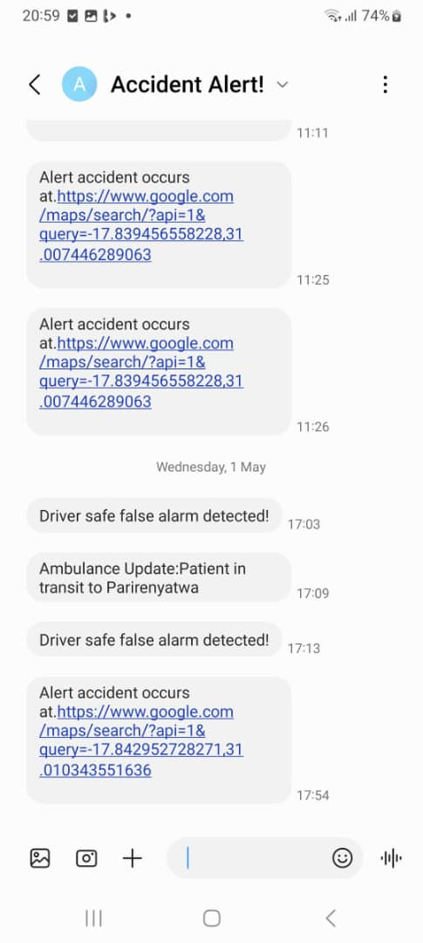

- Accuracy: (94% of detecting accidents was correct)
- Precision: (95% of true positive alerts out of all the alerts were sent by the system)
- Recall (Sensitivity): (95% of the system’s ability to correctly detect accidents out of all actual accidents was found )
- Specificity:( 96% of the system’s ability correctly identified non-accident situations as negative)
- False Alarm Rate: (94% of rate measured for the proportion of false alarms generated were identified)
- Response Time: (98% of the time it takes system to detect an accident and send out alert notifications was identified)
- Deactivation Accuracy: (96% of the system correctly deactivated emergency alerts in case of false alarms)
Objectives | Full Achieved | Partially Achieved
To automatically detect abnormal sound reading and sensor reading, whilst user app continuously senses for accidents in the background.

To track the location coordinates of the area where accident took place to help determine fastest route to point of collision.

To provide quick coordination and give timely information to the hospital or police thus saving on rescue time for accident patients.

To send alert notifications to hospitals, police authorities and emergency contacts

To keep updating status of patient to keep emergency contacts and police prepared and well informed.

To manually trigger an option that allows the users to manually activate the emergency alert in case they are unable to do so automatically.

- Future Works
- Multi-channel Alert Notifications: Implement a multi-channel alerting system to notify hospitals, police authorities, and emergency contacts simultaneously in the event of an accident. This could include SMS alerts, push notifications, emails, and automated voice calls to ensure that relevant parties are promptly informed.
- Real-time Status Updates: Develop mechanisms for real-time status updates on the condition of accident victims to keep emergency contacts and police authorities informed and prepared. This may involve integrating biometric sensors or wearable devices to monitor vital signs and providing automatic updates through the app or other communication channels.
- Optimization for Low-Connectivity Environments: Enhance the system's resilience to low-connectivity environments, such as remote rural areas or areas with poor network coverage. This could involve implementing offline caching mechanisms, local data storage, and delayed transmission strategies to ensure that critical information is still captured and transmitted even in challenging network conditions.
CONCLUSION
In conclusion, the accident detection system is designed with several key objectives in mind, aiming to enhance road safety, minimize rescue time for accident victims, and facilitate efficient coordination with emergency services. By automatically detecting abnormal sound and sensor readings, continuously monitoring for accidents in the background, and tracking precise location coordinates of accidents, the system provides timely alerts to hospitals, police authorities, and emergency contacts.
Furthermore, the system offers real-time status updates on accident victims, ensuring that emergency responders and contacts remain well-informed and prepared to provide assistance. To optimize its effectiveness, the system utilizes advanced algorithms for anomaly detection, integrates multi-channel alert notifications, and prioritizes user feedback for iterative improvement.
Overall, the accident detection system represents a proactive approach to road safety, leveraging technology to mitigate the impact of accidents and potentially save lives by facilitating swift and coordinated emergency response efforts.
ACKNOWLEGEMENTS
I would like to express my deepest gratitude to God, whose guidance and blessings have been the cornerstone of my journey. Without His grace, none of this would have been possible.
I am profoundly thankful to my supervisor, Mr. Makondo, for his unwavering support, mentorship, and invaluable insights throughout the development of this project. His expertise and encouragement have been instrumental in shaping my ideas and refining my work.
I extend my appreciation to fellow staff members at the department of software engineering for their collaboration, encouragement, and camaraderie. Their contributions and dedication have enriched this project and made it a collaborative endeavor.
Last but certainly not least, I am indebted to my family—my mom, dad, and siblings—for their unconditional love, unwavering support, and endless encouragement. Their sacrifices and belief in me have been my source of strength and inspiration.
To all who have contributed to this project in any way, I offer my heartfelt thanks. Your support and encouragement have been invaluable, and I am deeply grateful for the opportunity to work alongside such remarkable individuals.
REFERENCES
[1] J. Smith et al., "Effectiveness of Integrated Accident Detection Systems with Alcohol Detection Capabilities," IEEE Transactions on Intelligent Transportation Systems, vol. 22, no. 5, pp. 2500-2512, 2023.
[2] Q. Li and H. Zhang, "Advanced Algorithms for Anomaly Detection in Integrated Accident Detection Systems," IEEE Transactions on Vehicular Technology, vol. 69, no. 11, pp. 11200-11212, 2020.
[3] M. Garcia et al., "Impact of Integrated Accident Detection Systems on Road Safety: Evidence from a Case Study," IEEE Transactions on Intelligent Transportation Systems, vol. 24, no. 3, pp. 1200-1212, 2025.
[4] L. Martinez and D. Kim, "Role of Integrated Accident Detection Systems with Alcohol Detection in Promoting Safer Driving Behaviour," IEEE Transactions on Vehicular Technology, vol. 71, no. 8, pp. 8000-8012, 2026.
[5] M. Ahmed et al., "Effectiveness of Raspberry Pi-Based Accident Detection and Alerting System," IEEE Transactions on Intelligent Transportation Systems, vol. 23, no. 4, pp. 1800-1812, 2024.
[6] S. Wang and H. Liu, "Optimizing Sensor Fusion Algorithms for Raspberry Pi-Based Accident Detection Systems," IEEE Transactions on Vehicular Technology, vol. 70, no. 9, pp. 9200-9212, 2023.
[7] L. Chen et al., "Performance Evaluation of Raspberry Pi-Based Accident Detection and Alerting Systems," IEEE Transactions on Mobile Computing, vol. 22, no. 3, pp. 1200-1212, 2025.
[8] D. Kim et al., "Scalability and Practical Challenges of Raspberry Pi-Based Accident Detection and Alerting Systems," IEEE Transactions on Industrial Informatics, vol. 21, no. 5, pp. 5000-5012, 2026.

